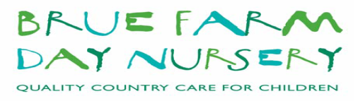
Tapestry On Line Learning Journal Policy
Brue Farm Day Nursery uses Tapestry. Tapestry is an online learning journey that records individual childrens learning and development, their achievements and progress. Tapestry allows staff to record observations in the form of written, photos and/or videos.
On registration, Parents/ Carers are asked to sign a Parent/Carer Tapestry Agreement form which gives permission for Brue Farm Day Nursery to take photos/videos for individual use on their Tapestry account as well as group photos/videos which are shared on other children’s Tapestry profiles. Please see the Parent/Carer Tapestry Agreement.
Parents/Carers have a secure login to access and view their individual child’s observations. Parents/Carers can add comments to the observations as well as add their own observations of activities that their child has been doing outside of nursery to share with staff at Brue Farm Day Nursery,
Observations are linked to the Early Years Foundation Stage and Characteristics of Effective Learning that shows the development that the child is making.
Tapestry can be used as a means for Parents/Carers to communicate with their key worker and visa versa. Any messages that have been added, for example needing more nappies, wipes or reminders of events/activities are deleted once actioned.
At the end of the child's time at Brue Farm Day Nursery the Parents/Carers will have a copy of their complete profile with all of their observations and summaries as a keepsake and record of their time at BFDN. This will be sent as a link by email. The child’s profile will automatically be deleted 3 months after the child has left the setting and Parents/Carers will no longer be able to access their child’s Tapestry account after this time.
A child’s Tapestry profile may be shared with another setting, without images, with permission of the Parents/Carers, if requested by another setting on leaving Brue Farm Day Nursery.
This Policy links to the Safeguarding & Welfare Requirements:
Child Protection: 3.4
A Unique Child: 1.3 Keeping Safe
Positive Relationships: 2.1 Respecting Each Other
Key Person: 3.26Information for Parents & Carers: 3.72
Positive Relationships: 2.2 Parents as Partners 2.4 Key Person
This Policy links to all the EYFS overarching principles
This Policy was created by the owner/manager Kath Farthing in August 2022
To be reviewed in 12 months time or earlier if required.

